APPLICATION FORM STAGE 1

Dear applicant,
Please fill in this general check list, which forms the first stage of your application for a ValuSect VOUCHER.

Contact details
Applicant name _________________________________________________________________
Postal address ___________________________________________________________________
Country_________________________________________________________________________
City ____________________________________________________________________________
E-mail__________________________________________________________________________
Phone_______________________________________________________________________

Company details
Please confirm with a cross (X) whether you meet the criteria:
- You are an SME¹
Company name: _____________________________________________________________
Headoffice located in:__________________________________________________________
Year of formal establishment: ___________________________________________________
VAT number: ______________________

General criteria
- Your business is part of the food and beverage or agri-food sector.

- You are part of, or want to become part of, the network that uses insects as food for human consumption.
- Your application refers to one or more of the three species (Tenebrio molitor, Acheta domesticus, Locusta migratoria)

- You have an innovative idea supporting the development of the European market for insects for human consumption.
My idea is: (Max. 250 words)

- You can show clearly in your application how the development/implementation of your idea supports the acceleration of the insects for human consumption market in Europe.
How does your idea support the acceleration of the European market for insects for human consumption? (Max. 250 words)

Which of these four service areas best suits your needs? (only one choice)
- Technological services
- Food development and innovation
- Consumer acceptance
- Strategic business services
This area fits best my idea because.....

Which of these services might be suitable to support your request/idea (You can choose more than one):
- Want to measure emissions/greenhouse gases
- Want to optimise any of the following: breeding, feeding, substrate, productivity, food safety, shelf life, and/or nutritional quality
- Want to develop/optimise technology
- Want to understand about the consumer needs/acceptance in target markets
- Want to develop a food product for human consumption which contains insect ingredients
- Want to develop suitable marketing strategies to promote food products which contain insects
- Want to propose a new innovative idea which does not fit in one of these categories but still supports the goal of accelerating the European insect market for human consumption.

This (these) service(s) is/are required for my idea because it/they will enable me to…..

- The applicant is aware of the fact that the support granted by the ValuSect voucher scheme is de-minimis support and hereby declares, that a de-minimis self-declaration will be provided together with an application in stage 2 (stage 2 is required after approval of stage 1).
- The applicant agrees with the private data policy agreement (LINK)

_________________________________ _________________________________
Signature Date/place

Thank you for your application!

Next Steps
The ValuSect team will complete an initial evaluation of your idea. You will receive feedback from the ValuSect team by: 31/01/2021.
Depending on the outcome of the initial evaluation, you may then:
- Be invited to submit a 2nd stage application; or
- Receive feedback about why your 1st stage application was not successful (in this case you might consider trying again in our next open call in December 2021)

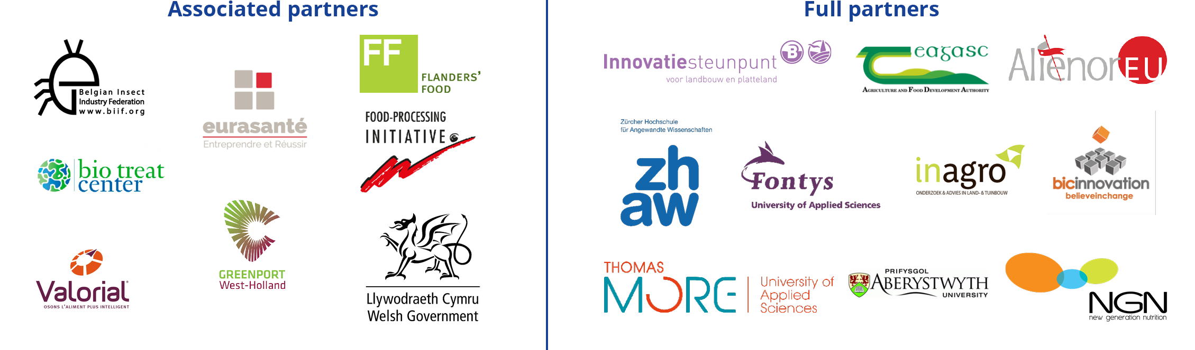

Definition of an SME eligible for ValuSect Open Calls An SME will be considered as such if complying with the European Commission Recommendation 2003/361/EC4 and the SME user guide5. As a summary, the criteria which define an SME are: - Independent (not linked or owned by another enterprise), in accordance to Recommendation 2003/361/EC3 - It is a legal entity established and based in one of the Interreg NWE (associated) country6 - Headcount in Annual Work Unit (AWU) less than 250. - Annual turnover less or equal to €50 million OR annual balance sheet total less or equal to €43 million For British applicants: Please be aware that eligibility criteria must be complied with for the entire duration of the grant. If the United Kingdom withdraws from the EU during the grant period without concluding an agreement with the EU ensuring in particular that British applicants continue to be eligible, you will cease to receive EU funding (while continuing, where possible, to participate) or be required to leave the project. In that case, the rules of H2020 grants will apply.

