Application form

Call 3

Insects for feed applications

Dear applicant,
Please fill in this general check list, which forms the first stage of your application for a ValuSect VOUCHER.

Contact details

Applicant name:

Postal address:

Country:

City:

E-mail:

Phone:

Company details
Please confirm with a cross (X) whether you meet the criteria:
- You are a SME
Company name:
Legal Form:
VAT number:
Official address:
Country:
City:
Year of formal establishment:

General criteria
- Your business is part of the animal feed or agri-feed sector

- You are part of, or want to become part of, the network that uses insects as feed for animal consumption

- Your application refers to one or more of the four involved insect species (Tenebrio molitor, Acheta domesticus, Locusta migratoria, Hermetia illucens)

- You have an innovative idea that supports the development of the European market for insects for feed applications

- You can show clearly in your application how the development/implementation of your idea supports the acceleration of the insects for animal feed market in Europe
How does your idea support the acceleration of the European market for insects for animal consumption? (Max. 250 words)

Which of these four service areas best suits your needs? (one choice only)
- Technological services
- Food development and innovation
- Marketing and communication services
- Strategic business services
This area fits best my idea because.....

Which of these services might be suitable to support your request/idea (you can choose more than one):
- Want to measure emissions/greenhouse gases
- Want to optimise any of the following: breeding, feeding, substrate, productivity, food safety, shelf life, and/or nutritional quality
- Want to develop/optimise technology
- Want to gain knowledge on producers needs and acceptance in target markets
- Want to develop a feed product for animal consumption which contains insect ingredients
- Want to develop suitable marketing strategies to promote feed products which contain insects
- Want support to connect with stakeholders and communicate results, as in events or publications scientific
- Want to propose a new innovative idea which does not fit in one of these categories but still supports the goal of accelerating the European insect market for animal consumption

This (these) service(s) is/are required for my idea because it/they will enable me to…..

- The applicant is aware of the fact that the support granted by the ValuSect voucher scheme is de-minimis support and hereby attach a signed de minimis declaration and a signed SME declaration to the application mail.

- The applicant agrees with the data privacy policy agreement

Specific criteria
- Title and summary
Mention a title for the case and briefly describe your idea, including the main goal and expected results. Consider that, if the application is selected, the summary will be published through all communication channels of the project, therefore it should not contain confidential information (max. 250 words).

- Introduction
Describe the problem, challenge, need or opportunity in which you would like to be supported.

- Innovation
ValuSect wants to enhance innovation in the insect-based feed sector. Therefore, it is important to highlight the innovative character of your proposal.
What is the current status of your idea/the level of innovation?

- Relevance
Describe how the proposal is relevant to the overall insect-based feed market and/or insect industry.

- Goal
Describe your intended project results that would be achieved through the use of the ValuSect service vouchers.

- Network
Describe other parties that are involved in the proposal (if any). Name them and briefly describe the part they will or can take in this application.

- Services
Mention the service(s) relevant for your case as they are described in the ValuSect Menu of Services. More than one service can be suggested.

- Applicability
Show how you will apply the results obtained to the North-West Europe insect-based feed sector. What is the contribution of the proposal to the sector?

_________________________________ _________________________________
Signature Date and place

Thank you for your application!
Mail this application form to valusect@thomasmore.be before the deadline (21/02/2022) and remember to include the signed de-minimis declaration and SME-declaration.

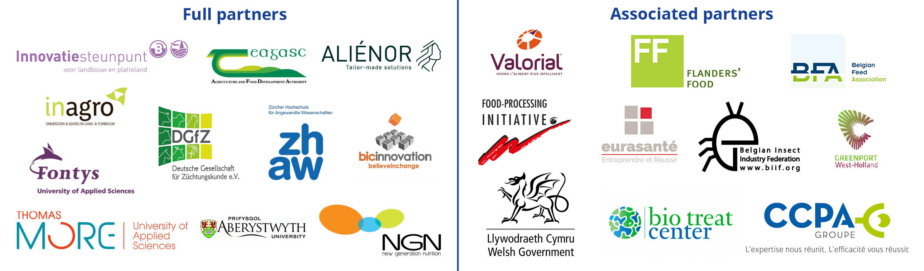

Definition of an SME eligible for ValuSect Open Calls An SME will be considered as such if complying with the European Commission Recommendation 2003/361/EC4 and the SME user guide5. As a summary, the criteria which define an SME are: - Independent (not linked or owned by another enterprise), in accordance to Recommendation 2003/361/EC3 - It is a legal entity established and based in one of the Interreg NWE (associated) country6 - Headcount in Annual Work Unit (AWU) less than 250. - Annual turnover less or equal to €50 million OR annual balance sheet total less or equal to €43 million

