Interreg North-West Europe

Call 3 Small-scale Projects Application form Template

DISCLAIMER

This document is made available for demonstration and information purposes only.
In accordance with Regulation (EU) No 2021 / 1059 of the European Parliament and of the Council, together with the decision of the Member States of the Interreg NWE Programme to use the Jems (Joint Electronic Monitoring System) for the submission of project proposals, this document cannot be used at any point in time to submit a project proposal to any of the calls published by the Interreg NWE Programme. All project submissions must be made via Jems.
The structure and content of the Application form in this template are indicative. The Interreg NWE Programme cannot be held accountable for any discrepancies between this document and the final application form which will be made available on the Jems at the opening of calls. If any such discrepancies arise, the Jems shall prevail.

PART A – Project identification

A.1 Project identification

*Asterisks indicate information required for saving.

Please be aware there may be gaps in the numbering of sections, due to the Programme’s configuration of the application form for this call.

Project ID |  | Automatically generated according to programme rules in their monitoring system
Name of the Lead Partner organisation |  | Automatically filled in according to section B – project partners
Name of the Lead Partner organisation in English |  | Automatically filled in according to section B – project partners
Project acronym |  | Project title
Enter acronym here  Max 25 characters |  | Enter title here  Max 85 characters
Project duration (nr. of months)
Enter a number

Programme priority and specific objective that your project will contribute to

Programme priority* |  | Specific objectives*
Select from drop-down |  | Select from drop-down of objectives that belong to the selected programme priority (links to Part C)

A.2 Project summary

Please give a short overview of the project and describe:
- the common challenge of the programme area you are jointly tackling in your project;
- the overall objective of the project and the expected change your project will make to the current situation;
- the main outputs you will produce and those who will benefit from them;
- the approach you plan to take and why a transnational approach is needed;
- what is new/original about the project.

In English language [max 2000 characters]

In French language [max 2000 characters]

In German language [max 2000 characters]

In Dutch language [max 2000 characters]

A.3 Project budget overview (automatically calculated.)

Programme funding |  |  | Contribution |  |  |  |  | Total  budget
Funding source | Funding amount | Co-financing  rate (%) | Automatic public contribution | Other public contribution | Total public contribution | Private contribution | Total contribution
ERDF |  | %
Total EU funds |  | %
Total project budget |  | %

A.4 Project outputs and result overview

Programme output indicator | Aggregated value per programme output indicator | Measurement unit | Output | Output title | Output target value | Programme result indicator | Baseline | Result indicator target value | Measurement unit
From WPs | Automatically calculated | From WPs | From WPs | From WPs | From WPs | From C.5 | From C.5 | From C.5 | From C.5

PART B – Project partners

B – Partners overview

Partner number | Status | Organisation abbreviation | Partner role | NUTS | Partner total eligible budget
Automatically filled in | Automatically filled in | Automatically filled in | Automatically filled in | Automatically filled in | Automatically filled in
Automatically filled in | Automatically filled in | Automatically filled in | Automatically filled in | Automatically filled in | Automatically filled in
Automatically filled in | Automatically filled in | Automatically filled in | Automatically filled in | Automatically filled in | Automatically filled in

Project partner 1

B.1.1 Partner identity

Partner role |  | List: lead partner, project partner
Abbreviated name of organisation* |  | Enter here  Max 15 characters
Name of organisation in original language |  | Enter here  Max 85 characters
Name of organisation in English |  | If existing, using the official translation  Max 85 characters
Department /unit / division |  | If applicable, enter here  Max 250 characters

Legal and financial information

Type of partner |  | Drop-down pre-defined list (see Annex 1 – Type of partner and target group classification)
Partner size |  | Drop-down pre-defined list
Legal status* |  | Drop-down (minimum this: public* / private* but there could be more options)
Sector of activity at NACE group level  Please refer to the statistical classification of economic activities NACE Rav. 2 (2008) available via the [Eurostat website]. |  | Drop-down pre-defined list  This fiels is only for state aid relevant activities
VAT number (or other identifier) |  | Enter here  Max 50 characters  If no VAT nr is available, another organisation identifier should be used.
Other identifier number |  | Enter here  Max 50 characters
Other identifier description |  | Enter here  Max 100 characters
PIC (from EC Participant Register) |  | Enter here

Advance Payment
Partners with micro-enterprise or ‘micro’ NGO status can request an advance payment. This status applies to enterprises or non-governmental organisations employing fewer than 10 people and whose annual turnover and/or annual balance sheet total does not exceed EUR 2 million.
The advance payment is limited to either €50,000 ERDF at partner level or 50% of the partner’s ERDF budget, whichever is the lowest.
Please refer to section 5 of the Programme manual for more information.

Tick box ”The organisation applies for an advance payment”

B.1.2 Partner address

Partner main address
Information about NUTS codes and how to identify your region: https://ec.europa.eu/eurostat/web/nuts/background

Country (Nuts 0) |  | Drop-down list
Region (Nuts 2) |  | Nuts 3
Drop-down list |  | Drop-down list
Street |  | House number
Enter here  Max 50 characters |  | Enter here  Max 20 characters
Postal code |  | City
Enter here  Max 20 characters |  | Enter here  Max 50 characters
Homepage |  | Enter here  Max 250 characters

Address of department / unit / division (if applicable)

Country (Nuts 0) |  | Drop-down
Region (Nuts 2) |  | Nuts 3
Drop-down |  | Drop-down
Street |  | House number
Enter here  Max 50 characters |  | Enter here  Max 20 characters
Postal code |  | City
Enter here  Max 20 characters |  | Enter here  Max 50 characters

B.1.4 Legal representative

Title |  | First name |  | Last name
Enter here  Max 25 characters |  | Enter here  Max 50 characters |  | Enter here  Max 50 characters

B.1.5 Contact person

Title |  | First name |  | Last name
Enter here  Max 25 characters |  | Enter here  Max 50 characters |  | Enter here  Max 50 characters

E-mail address |  | Telephone
Enter here  Max 255 characters |  | Enter here  Max 25 characters

B.1.6 Partner motivation and contribution
What is the role (contribution and main activities) of your organisation in the project?
Enter text here
3000 characters

Partner budget overview
Partner | Organisation abbreviation | Staff costs | Other costs | Lump sum |  |  |  |  | Total
Automatically filled in
Total Automatically filled in

Partner budget options

Tick box ”Other costs Flat Rate: 40% of Staff costs (fixed rate)”
This option cannot be combined with any other flat rate option.
This is the only option for call 3 for small-scale projects.

Partner budget
All amounts in the budget are rounded down to 2 digits after the comma.

Staff costs
Staff function | Unit type | No. of units | Price per unit | Total
Enter text here  Max 255 characters | Enter text here | Enter a number here | Enter a number here | Automatically generated

Other costs flat rate
Flat rate for Other costs |  |  |  |  |  | Total
Automatically generated |  |  |  |  |  | Automatically generated

Partner lump sums
(assisgned in section E.1 – Project lump sums)
Programme lump sum | Lump sum cost | Partner share of lump sum cost
Total partner lump sums | Automatically generated | Automatically generated

Co-financing
Source* | Amount |  | Percentage
Partner total eligible budget %
Origin of partner contribution
Source of contribution Legal status of contribution* Amount % of total
partner budget
Total
Sub-total public contribution |  | %
Sub-total automatic public contribution |  | %
Sub-total private contribution |  | %
Total |  | %

State aid criteria self-check

Criterium I: Is the partner involved in economic activities within the project?
Please consider questions below, answer Yes/No and briefly justify.

State Aid question | Answer | Justification
- Will the partner implement activities and/or offer goods/services for which a market exists? | Yes/No | Enter text here  Max 1000 characters
- Are there activities/goods/services that could have been undertaken by an operator with the view of making profit (even if this is not the partner’s intention)? | Yes/No | Enter text here  Max 1000 characters

Criterium II: Does the partner receive an undue advantage in the framework of the project?

Please consider questions below, answer Yes/No and briefly justify.
State Aid question | Answer | Justification
- Does the project applicant plan to carry out the economic activities on its own i.e. not to select an external service provider via public procurement procedures for example? | Yes/No | Enter text here  Max 1000 characters
- Will the project applicant, any other operator not included in the project as a project partner or the target audience gain any benefits from its project economic activities, not received in the normal course of business (i.e. not received in the absence of funding granted through the project)? | Yes/No | Enter text here  Max 1000 characters

State aid relevant activities (select from drop-down menu based on C.4 entries) |  | Multiple choice selection of project partner's WP activities Numbers from C.4. work plan
 | State aid regime (to be filled in ONLY after project selection) | Drop down list (GBER article 20/ GBER article 20a / de minimis)

Associated organisations

Name of organisation in original language |  | Enter here  Max 100 characters
Name of organisation in English |  | If existing, using the official translation  Max 100 characters
Partner |  | Link to a partner who is supported by this associated organization  Drop-down list

Country (Nuts 0) |  | Drop-down
Region (Nuts 2) |  | Nuts 3
Drop-down |  | Drop-down
Street |  | House number
Enter text  Max 50 characters |  | Enter text  Max 20 characters
Postal code |  | City
Enter text  Max 20 characters |  | Enter text  Max 50 characters

Legal representative

Title |  | First name |  | Last name
Enter here  Max 25 characters |  | Enter here  Max 50 characters |  | Enter here  Max 50 characters

Contact person

Title |  | First name |  | Last name
Enter here  Max 25 characters |  | Enter here  Max 50 characters |  | Enter here  Max 50 characters

E-mail address |  | Telephone
Enter here  Max 255 characters |  | Enter here  Max 25 characters

Please describe the role of the associated organisation in the project.
Enter text here
Max 3000 characters

B.2 Project partner 2 […]

All sections from B.1 repeat

PART C – Project description

C.1 Project overall objective

Below, you can see the Programme priority specific objective your project will contribute to (chosen in section A.1.).

Programme priority specific objective | Automatically filled in

Project overall objective

Now think about your main objective – what do you aim to achieve by the end of your project? Remember your project needs to contribute to the programme’s objective.

Your objective should:
- be realistic and achievable by the end of the project, or shortly after;
- specify who needs project results and in which territory;
- be measurable – indicate the change you are aiming for.

Project overall objective | Programme priority specific objective
Enter text here  Max 500 characters | Automatically inserted once it is selected in section A.1

C.2 Project relevance and context

C.2.1 What are the common territorial challenge(s) that will be tackled by the project?
Please describe the territorial challenges and opportunities your project addresses in the NWE area. Why is transnational cooperation needed to address these challenges and opportunities?

Enter text here
Max 2000 characters

C.2.2.a - How does the project tackle identified common challenges and/or opportunities?
Please describe if your project activities will develop and test new approaches; and/or if they will adapt and implement existing approaches for further uptake.

Enter text here
Max 2000 characters

C.2.7 How does the project build on available knowledge?
Please describe what the project draws on e.g., from EU and/or other projects, and other available knowledge, and how the project capitalises on this knowledge.

Enter text here
Max 1000 characters

C.3 Project partnership

Describe the structure of your partnership and explain why these partners are needed to implement the project and to achieve project objectives.
Please describe the final partnership composition, partners? roles, and how they will interact and cooperate.

Enter text here

Max 4000 characters

C.4 Project work plan

A maximum of 3 work packages is allowed in every project work plan in a regular call.
In the case of a call for small-scale projects, only 1 work package is allowed.
Please be aware that you will not be able to submit your AF if you are above this limit.

C.4.1 Work package 1

Work package number | Automatically generated
Work package title | Enter the title here  Max 100 characters

Project Specific Objective

Your objective should be:

- realistic and achievable by the end of the project;
- specific (who needs project outputs delivered in this work package, and in which territory);
- measurable – indicate the change you are aiming for.

Define one project specific objective that will be achieved when all activities in this work package are implemented and outputs delivered.

Project specific objective | Enter project specific objective here  Max 1000 characters
Think about the communication objective that will contribute to the achievement of the specific objective.
Communication objectives aim at changes in a target audience's behaviour, knowledge or belief.

Communication objective(s) and target audience | Communication objective and target audience  Max 1000 characters

Work package summary
Please provide a summary of your work package.
Enter text here

Max 1000 characters

List of activities

Please describe the activities by which the project achieves the project specific objective and related communication objective(s).

Each Work package must include at least one communication activity and deliverable which will allow for the communication objective(s) to be reached.

If relevant, the Work package should also include a long-term effects activity and deliverable which will ensure the long-term effects of project outputs and results.

Ac Nr. | Activity title | Start period | End period | Activity description
A 1.1 | Enter text  Max 200 characters | Select the period from drop-down | Select the period from drop-down | Enter text  Max 3000 characters
A 1.2 | Enter text  Max 200 characters | Select the period from drop-down | Select the period from drop-down | Enter text  Max 3000 characters
A 1.3 | Enter text  Max 200 characters | Select the period from drop-down | Select the period from drop-down | Enter text  Max 3000 characters
A 1.4 | Enter text  Max 200 characters | Select the period from drop-down | Select the period from drop-down | Enter text  Max 3000 characters
A 1.5 | Enter text  Max 200 characters | Select the period from drop-down | Select the period from drop-down | Enter text  Max 3000 characters

Deliverables

Add deliverables to your activity – see programme rules

Del Nr. | Title | Delivery period | Description
D 1.1.1 | Enter text here  Max 100 characters | Select the period from drop-down | Enter text here  300 characters

Outputs

Regarding the drop-down list of ‘Programme output indicators’:
For every project output you define, you must choose one Programme output indicator to contribute to from the drop-down list and quantify your contribution.
Overall, as a project you must contribute to a minimum of 2 out of the 4 following output indicators.
Important: Please note that if you choose output indicator O.2 then you must also choose output indicator O.3 AND one more output indicator for a total of 3 out of 4 (e.g., O.2, O.3 and O.4).
- O.1: Strategies and action plans jointly developed
- O.2: Pilot actions developed jointly and implemented in projects
- O.3: Jointly developed solutions
- O.4: Participations in joint training schemes

For small-scale project calls, please note that you must contribute to 1 output indicator only (O.1, O.2+O.3 or O.4 as indicated above).
Important: Outputs O.2 and O.3 are interrelated and count as 1 output indicator. Pilot actions always lead to joint solutions and joint solutions are developed in project activities organised as pilot actions. So, by choosing O.2 projects must also choose O.3 and vice versa.

Output Nr. | Output title | Programme output indicator | Measurement unit | Delivery period | Output description
OI 1.1 | Enter text  Max 200 characters | Choose from the drop-down list | Automatic | Drop-down | Describe in more detail what will be delivered  Max 500 characters
OI 1.2 | Enter text  Max 200 characters | Choose from the drop-down list | Automatic | Drop-down | Describe in more detail what will be delivered  Max 500 characters
OI 1.3 | Enter text  Max 200 characters | Choose from the drop-down list | Automatic | Drop-down | Describe in more detail what will be delivered  Max 500 characters
OI 1.4 | Enter text  Max 200 characters | Choose from the drop-down list | Automatic | Drop-down | Describe in more detail what will be delivered  Max 500 characters

C.5 Project results

What do you expect to change because of the activities you plan to implement and the outputs you plan to deliver? Please take a look at the programme result indicators and select those that you will contribute to.

Regarding the drop-down list of ‘Programme result indicators’:
For every project result you define, you must choose one Programme result indicator to contribute to from the drop-down list and quantify your contribution.
Overall, as a project, you must contribute to a minimum of 2 out of the 3 following result indicators.
Make sure they correspond to the output indicators you have chosen:
- R.1: Joint strategies and action plans taken up by organisations
- R.2: Solutions taken up or up scaled by organisations
- R.3: Completion of joint training schemes
In addition to the 2 chosen from the list above, please note R.4 ‘Organisations with increased institutional capacity due to their participation in cooperation activities across borders’ must be contributed to by default by all projects.

For small-scale project calls, please note that you must contribute to 1 result indicator only
(R.1, R.2 or R.3 as indicated above).
In addition, you must also contribute to the mandatory result indicator R.4 ‘Organisations with increased institutional capacity due to their participation in cooperation activities across borders’.

Result Nr. | Programme result indicator | Measurement unit | Result indicator baseline | Result indicator target value | Delivery period | Result description
RI 1 | Choose from the drop-down list | Automatic | Automatically retrieved from programme data | Enter the number | Drop-down | Describe in more detail the change expected  Max 1000 characters
RI 2 | Choose from the drop-down list | Automatic | Automatically retrieved from programme data | Enter the number | Drop-down | Describe in more detail the change expected  Max 1000 characters
RI 3 | Choose from the drop-down list | Automatic | Automatically retrieved from programme data | Enter the number | Drop-down | Describe in more detail the change expected  Max 1000 characters

C.6 Time plan

Work packages and activities | Period 1 | Period 2 | Period 3 | Period 4 | Period 5 | Period 6
WP 1: Title
A 1.1 title
A 1.2 title |  |  | Deliverable  1.2.1
A 1.3 title
A 1.4 title
OI 1.1
OI 1.2

C.7 Project management

In addition to the thematic work you will do in your project, you will need time and resources for coordination and internal communication. Please describe below how you plan to organise yourself to ensure the project work runs smoothly.

C.7.1 How will you coordinate your project?
Who will be responsible for coordination? Will you have any other management structures (e.g., thematic groups, WP managers)? How will the internal communication work?

Enter text here
Max 2000 characters

C.7.2 Which measures will you take to ensure quality in your project?
Quality management: How will you ensure project quality (quality control measures)?
Risk management: List the three main risks of your project and potential mitigation measures.

Enter text here /Max 3000 characters

C.7.3 What will be the general approach you will follow to communicate about your project?
Who will coordinate project communication and how will he/she ensure the involvement of all partners? How will the communication function contribute to uptake and scale up of your project results? Please note that all communication activities, including a compulsory communication strategy as first deliverable, should be included in the work packages as an integral part of your project. There is no need to repeat this information here.

Enter text here
Max 3000 characters

C.7.5 Cooperation criteria
Please select all cooperation criteria that apply to your project and describe how you will fulfil them.
Cooperation criteria |  | Description
Joint Development* |  | Enter text here  Max 250 characters
Joint Implementation* |  | Enter text here  Max 250 characters
Joint Staffing |  | Enter text here  Max 250 characters
Joint Financing |  | Enter text here  Max 250 characters

C.7.6 Horizontal principles
Please indicate which type of contribution to horizontal principles applies to the project and justify your choice.
Horizontal principles | Type of contribution | Description of the contribution
Sustainable development | Select one of the following options: positive effects, neutral, negative effects | Enter text here  Max 250 characters
Equal opportunities and non-discrimination | Select one of the following options: positive effects, neutral, negative effects | Enter text here  Max 250 characters
Equality between men and women | Select one of the following options: positive effects, neutral, negative effects | Enter text here  Max 250 characters

AF annexes: attachments

Only explicitly allowed documents should be provided in attachment (see Programme Manual chapter 4).

Budget tables

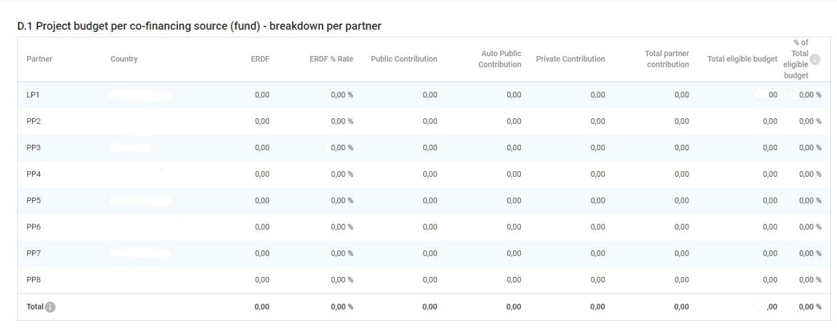

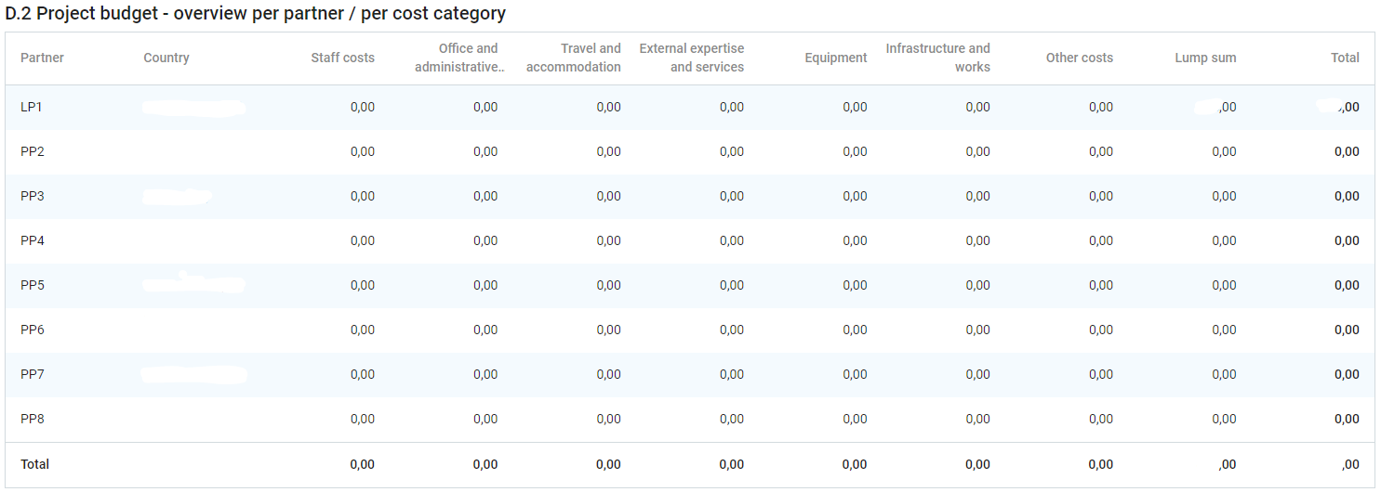

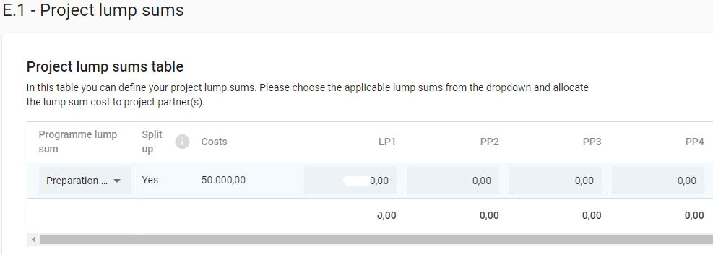

ANNEX 1 - Classification of type of partners and target groups

Nr | Main categories | Examples | Measurement unit
1 | Local public authority | municipality, etc. | [number of organisations]
2 | Regional public authority | regional council, etc. | [number of organisations]
3 | National public authority | ministry, etc. | [number of organisations]
4 | Sectoral agency | local or regional development agency, environmental agency, energy agency, employment agency, etc. | [number of organisations]
5 | Infrastructure and (public) service provider | public transport, utility company (water supply, electricity supply, sewage, gas, waste collection, etc.), airport, port, railway, etc. | [number of organisations]
6 | Interest groups including NGOs | international organisation, trade union, foundation, charity, voluntary association, club, etc. | [number of organisations]
7 | Higher education and research organisations | university faculty, college, research institution, RTD facility, research cluster, etc. | [number of organisations]
8 | Education/training centre and school | primary, secondary, pre-school, vocational training, etc. | [number of organisations]
9 | Enterprise, except SME |  | [number of enterprises]
10 | SME | micro, small, medium | [number of SME]
11 | Business support organisation | chamber of commerce, chamber of trade and crafts, business incubator or innovation centre, business clusters, etc. | [number of organisations]
12 | EGTC |  | [number of organisations]
13 | International organisation, EEIG | under national law, under international law | [number of organisations]
14 | General public |  | [number of people]
15 | Hospitals and medical centres |  | [number of organisations]
16 | Other

Relevant only for target groups.

