NORTH-WEST EUROPE - PROJECT DEVELOPMENT
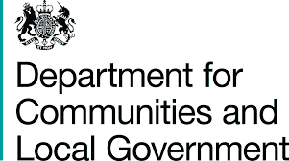
(MAX. 2 SIDES)

Project Title:

Objective
What are you doing; for who; why? Value for money should be demonstrated.

Need
What is the big challenge or problem in the territory which your project addresses?

Demand / Market Failure
Why should public Interreg funds be used to address this problem? What is the need for public intervention, which will not be provided by the market? How does it match NWE priorities?

Actions
What activities will your project deliver, which are in support of the project objective? In each case, ask yourself whether the action is justified by the objective you have set yourself. Value for money should be demonstrated.

Results
What is the change your project will create? What tangible outcomes will your project deliver on the ground? Focus particularly on results that will last after the project has finished. Do these results address the original need or challenge identified? Include the societal benefit of your final product/services/solutions. Value for money should be demonstrated.

Partnership
Why this partnership? What does the transnational element of the partnership bring to the project? All funded projects must involve partners from at least 3 different countries, 2 from within the NWE region, with a joint approach to tackle a common issue.

Risks
Any key risks should be identified and mitigated against.

Contact Details
Name

Organisation

Contact Email

Contact Tel.

