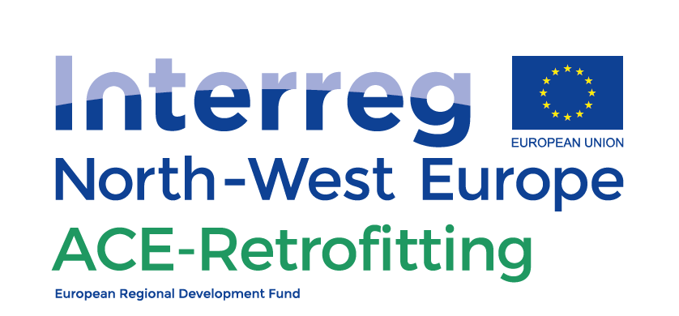

Supporting the “demand” side – Taking off
Project team charter

21.12.2018
Prepared by Maastricht University – Deliverable DT2.2.1 bis

Who is this tool for? | Project team  Condominium Board  Building manager
What is the purpose of this tool? | When you establish an in-house project team, it is important to agree on the mandate for the team. This tool provides a template and examples for a team charter
How to use this tool? | Read the general information and copy the template to your own word document.
Next steps | Take care of communication, expert information, voting, training, the project management plan, and coordinating the implementation of the project.

What is a team charter?
The charter describes the mandate of the team and provides authority to a (group of) person(s) to act accordingly. In the case of energy retrofitting in condominiums, the project team is mandated to speak in the name of the co-owners with all parties involved in the retrofitting project and to take certain actions.

Why is it important to formulate a team charter?
An energy retrofit of a condominium is a major project. It is important to know who will be allowed to make which decisions. Some decisions (e.g. unforeseen circumstances, budget overrun) might need the full consent of all co-owners, whereas other decisions (e.g. where to put a pipe or cable, when to suspend elevator service)) can be dealt with by the project team. The mandate will also indicate who is the first contact point between condominium and professionals and who will make decisions in emergencies.
TEAM CHARTER

Template for a team charter, with example text
The paragraphs below provide the starting point for your own team charter; adjust according to your needs and wishes.
- Context: in our condominium we are creating an energy retrofitting project. This project takes a holistic total-building approach. We use in our project sustainable products whenever possible. We (as a condominium) aim to lower the energy usage [could be specified according to the energy source] by xx% compared to [reference year].
In order to make this successful, we are setting up a project team. This team charter identifies the roles and responsibilities of the team.
- Purpose of team: the project team is the group of people who have the expertise needed for preparing, supervising and managing the condominium retrofit project and who act as the link between the professionals and the owners.
- Composition and Roles: The members of the project team have the following roles (take this from the tool “determine your capacity to manage an energy retrofit project”*)
  - Ms/Mr [insert name] is our expert for understanding and evaluating the technical solutions proposed and communicating with building professionals in the project planning phase
  - Ms/Mr [insert name] is our expert for understanding and evaluating the plans that are proposed by financial experts regarding funding of the retroftitting project (loans, subsidies, interest rates, payback terms, etc)
  - Ms/Mr [insert name] is our expert for checking progress of the works and evaluating if the works are up to the agreed standard
  - Ms/Mr [insert name] is our expert for understanding and evaluating the retrofitting plans in terms of energy efficiency gains and in terms of different energy efficiency solutions that are proposed
  - Ms/Mr [insert name] is our expert for communication of complex information to the other owners
  - Ms/Mr [insert name] is our expert for coordinating this project team
- Authority: The team will work within the boundaries set by the Association of Co-owners. The budget we agreed upon is xxxx€. Any deviation from the budget of more than xx% will be discussed with the Board of the Association of co-owners who will decide whether to call a meeting of all members. The time frame we agreed upon was xxxx months. Any deviation from the planning of more than xx% will be discussed with the Board of the Association of Co-owners who will decide whether to call a meeting of all members.
- Meetings with Board: the project team will meet each [xx-day] to discuss progress with the Board of the Association of Co-owners to discuss progress
- Team cooperation: the project team works according to the following rules:
  - We listen to each other and the other co-owners in a respectful way.
  - During the preparation phase, the team members will together prepare the plans to be presented to the co-owners.
  - During the project the team briefly meets every morning with the builders to quickly go through the work of the previous day as well as that of the coming day.
  - Every week a progress outlook for the coming week and the total project will be discussed with the builder’s coordinator.
- Emergencies: In case an emergency occurs, the project team (or the members who are present) is entitled to take action to prevent damage to the property as much as possible. As soon as possible the condominium Board as well as the other team members will be contacted and taken on board into the decision-making process.
- Signatures: make sure to get this document signed by the condominium Board, as well as by all project team members.

*: the tool “determine your capacity to manage an energy retrofit project” can be found on the left:

