LOCATION
The meeting will take place in Rennes at Images & Reseaux on January 15th to 16st 2020.
IMAGES & RESEAUX
Campus de Beaulieu (building 9ª)
Allée Jean Perrin
35042 RENNES France
Latitude: N47.2285261°
Longitude : -1.6362523999999894
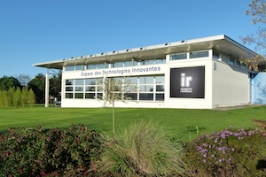
If you have any trouble reaching the office, please do not hesitate and contact Sara FREOUL: +33 223 21 00 50.
The meeting will be held in room “Canada”.

How to get to Images & Reseaux:

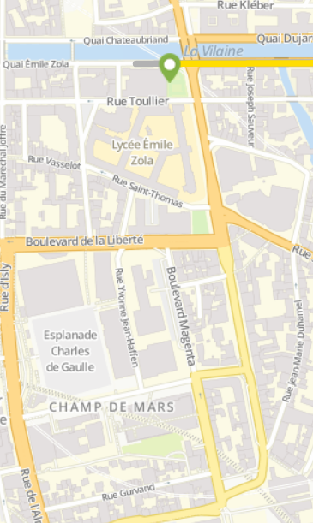
By train: There are trains departing from Paris to Rennes every hour (https://www.voyages-sncf.com/).
Beaux Arts bus stop
To get to Images & Reseaux the easiest way is to take a taxi in front of the train station (please note that the train stations is under construction).
There are also buses but you will need to walk for about 5-7 minutes from the station to the bus stop called Beaux Arts where you can take the bus number C4, C6 or 40ex. Images & Reseaux is at the bus stop called Les Préales.

Train station

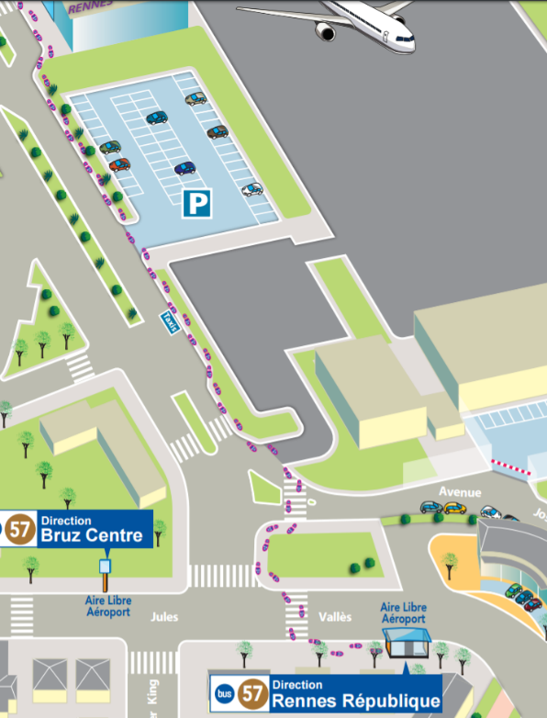
By plane: The bus n°57 takes you to the city center of Rennes (Republique station) in 20 minutes, every day of the week, the week-end and on public holidays. The nearest bus stop is located at the junction between Joseph Le Brix avenue and Jules Vallès avenue, 300m from the terminal building. Buses run every day and on public holidays.
There are also always taxis at the airport (taxi Rennes +33(0)2 99 30 79 79
Timetable: http://www.rennes.aeroport.fr/sites/rennes.aeroport.fr/files/horaires-bus-ligne-rennes-aeroport-2016.pdf
Code for Rennes Airport: RNS
It's not à big Airport you may need to have a connecting flight from Paris.

From the City Centre (République) to Images & Réseaux by bus:
Lines C4, C6 and 40ex all leave from République and stop at Les Préales:
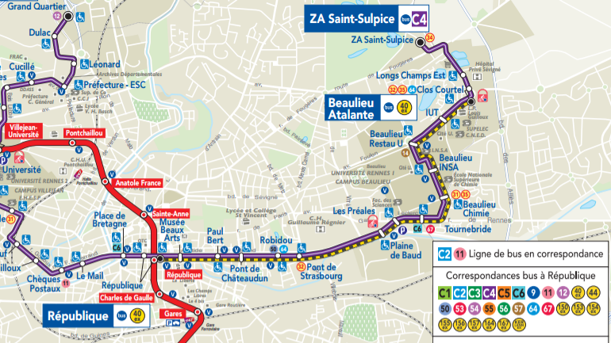

Recommended hotels in Rennes
We recommend you to make your own reservations on-line in the hotels closest to the city centre. Here are some suggestions:
Hotel Name | Category | Location | Contact Details
Campanile | *** | 28 Avenue Janvier, Rennes | Phone: +33 (0)2 99 31 59 59  Web: www.campanile.com/Rennes‎
Hotel Le Nemours | *** | 5 Rue de Nemours, Rennes | Phone: +33 (0)2 99 30 25 80  Web: www.kyriad.com/Rennes‎
Mercure Rennes Centre | **** | 1 rue Paul Louis Courier, Rennes | Phone : +33 (02) 99 78 82 20  Web : http://www.mercure.com/fr/hotel-1056-hotel-mercure-rennes-centre-parlement
Hotel Astrid | ** | 32 Avenue Louis Barthou, Rennes | Phone : +33 (0)2 99 30 82 38  Web: http://www.hotel-astrid-rennes.eu/
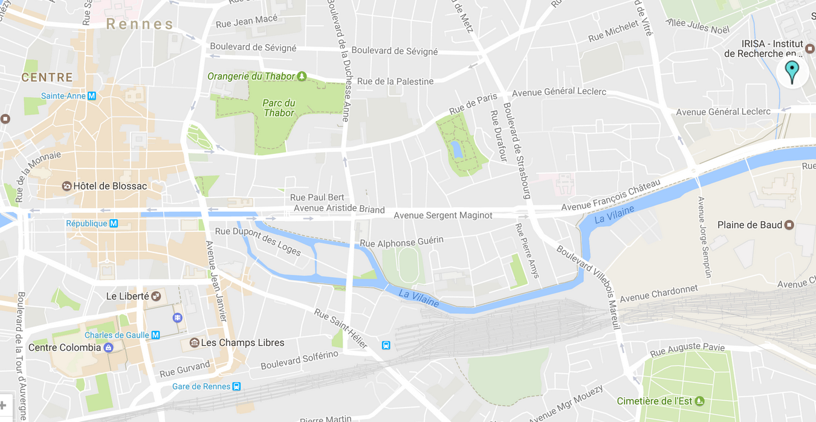
Map of city centre:
Republique
Train station
Images & Reseaux

